D197 - Version Control
Nicole Richards

Step A Screenshot
I initially could not find the correct tab with the repository graph, but I was able to take screenshots of where it would have been in the graph at the time. Below is a screenshot of the current repository graph in Gitlab after completing the steps in A:

Step B Screenshot
This is where I cloned the repository. Below is a screenshot of the command line action after completing the steps in B:
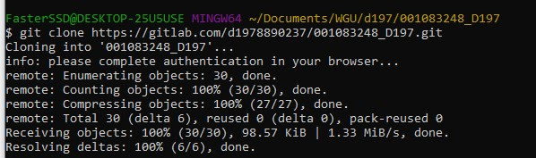

Step C Screenshot
The changes I made were to the language used to communicate with customers. I wanted to make it sound a bit more professional. Below is a screenshot for each git command for each change made to the HTML files after completing the steps in C:
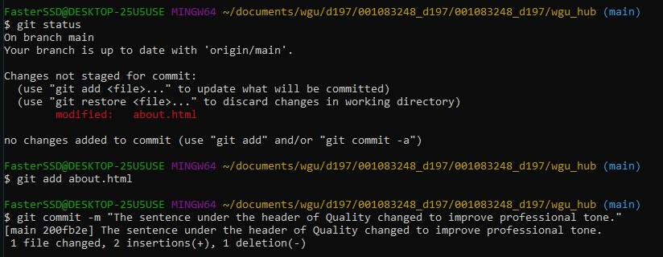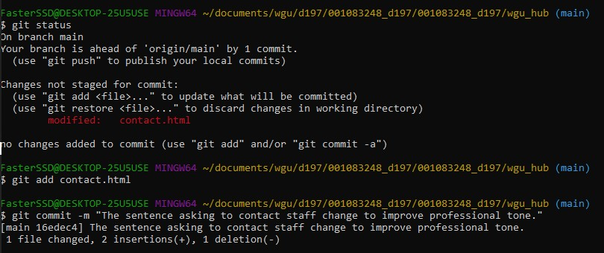
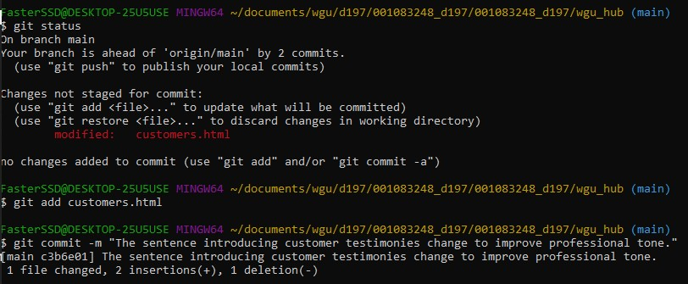
This is where I pushed the changes made in the repository. Below is a screenshot of the command line action after completing the steps in C:
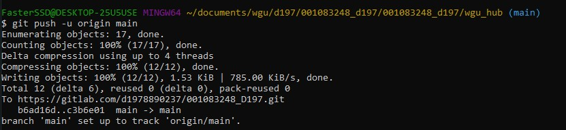

Step D Two Screenshots
Here is when I created a readme branch. Below is a screenshot of the command line action after completing the steps in D:
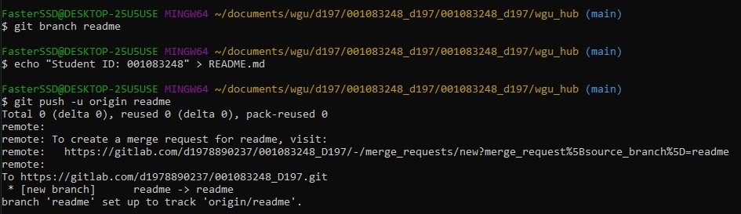
The readme branch was successfully created. Below is a screenshot of the current repository graph in Gitlab after completing the steps in D:
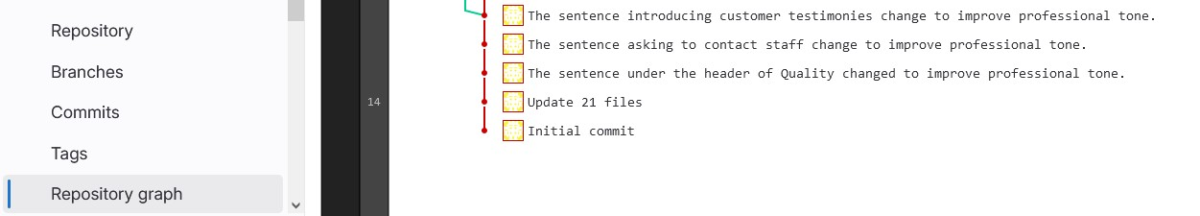

Step E Two Screenshots
This step was a bit tricky. I ended up creating many conflicts but was able to successfully edit the readme and push it to the repository. Below is a screenshot that demonstrates the conflict of a merge command line action after completing the steps in E:
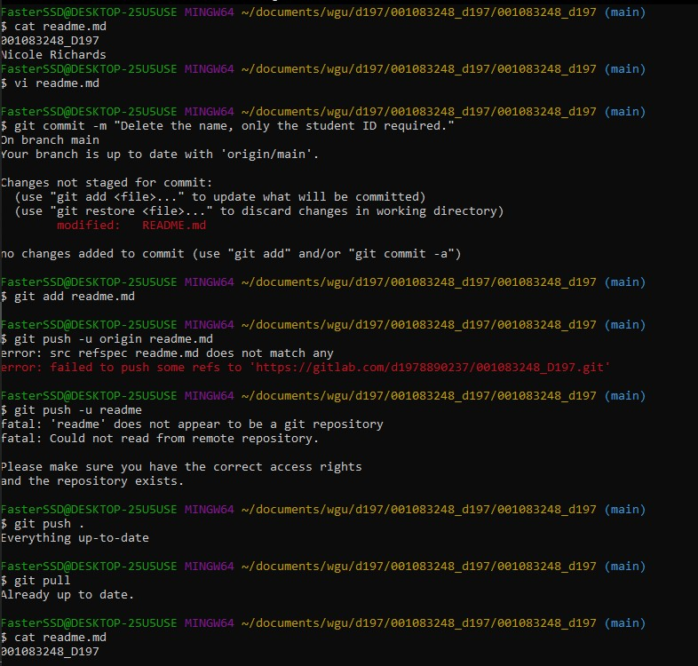
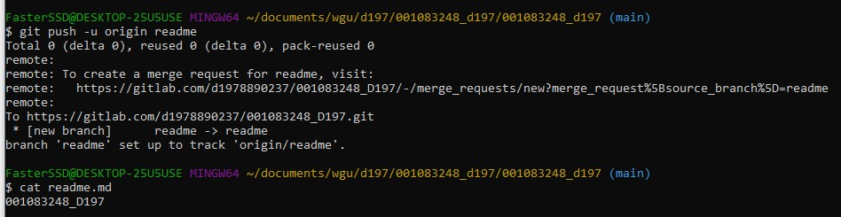
After several attempts, I successfully merged the branch. Below is a screenshot of the current repository graph in Gitlab after completing the steps in E:
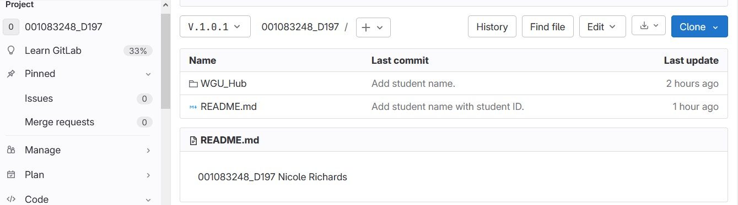

Step F Two Screenshots
I created a tag and commented it. Below is a screenshot of the command line action after completing the steps in F:
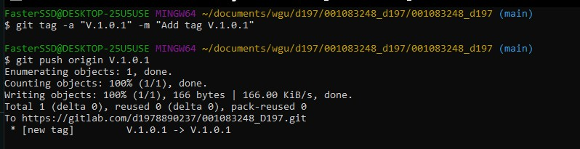
I selected the drop-down menu and was able to see my tag of V.1.0.1. Below is a screenshot of the current repository graph in Gitlab after completing the steps in F:
